Database Final Project Report

FOOD PRODUCTS

Team 3

Chaoran Li - cx190012

Miao Miao - mxm190020

Yinglu Huang - yxh190064

# **Project Description**

In this project, we design a datasystem for FOOD PRODUCTS, including data requirement for food products, ER diagram, relational schema, normalization, create table by using SQL/PL.

# **Achievement Exhibition**

1. Data Rquirement
2. ER Diagram

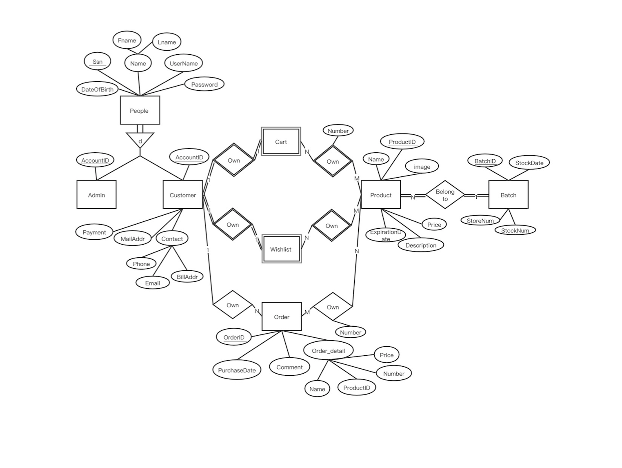

1. Map the ER diagram into relational model.

CUSTOMER (AccountID, Fname, Lname, DateOfBirth, SSN, UserName, Password, Payment, MailAddr, BillAddr, Phone, Email)

ADMIN (AccountID, Fname, Lname, DateOfBirth, SSN, UserName, Password)

BATCH (BatchID, ProductID[FK -> PRODUCT.ProductID], StoreNum, StockNum, StockDate)

PRODUCT (ProductID, Name, Price, Description, Image, ExpirationDate)

ORDER (OrderID, AccountID[FK -> CUSTOMER.AccountID], PurchaseDate, Comment)

ORDERDETAIL (OrderID[FK -> ORDER.OrderID], Name, ProductID, Number, Price)

ORDER_OWN_PRODUCT (OrderID[FK -> ORDER.OrderID], ProductID[FK -> PRODUCT.ProductID], Number)

CART (AccountID[FK -> CUSTOMER.AccountID])

CART_OWN_PRODUCT (AccountID[FK -> CUSTOMER.AccountID], ProductID[FK -> PRODUCT.ProductID], number)

WISHLIST (AccountID[FK -> CUSTOMER.AccountID])

WISHLIST_OWN_PRODUCT (AccountID[FK -> CUSTOMER.AccountID], ProductID[FK -> PRODUCT.ProductID])

1. Normalization

There is no functional dependency that would violate 3NF, so the relational model we got in step 3 is already in 3NF.

1. Final relational schema
2. Create tables
3. PL/SQL: Define two meaningful stored procedures and two triggers.